# How to use ESCAP Carbon Pricing Simulation tool

# How to Start

The simulation tool can be accessed by clicking [here](https://mybinder.org/v2/gh/IbHansen/UNESCAP-Asia/HEAD?urlpath=tree/Asia/Carbon%20tax%20experiments%20singel%20country.ipynb)

A new tab will open in your browser, and after a small delay it should look like the image below:

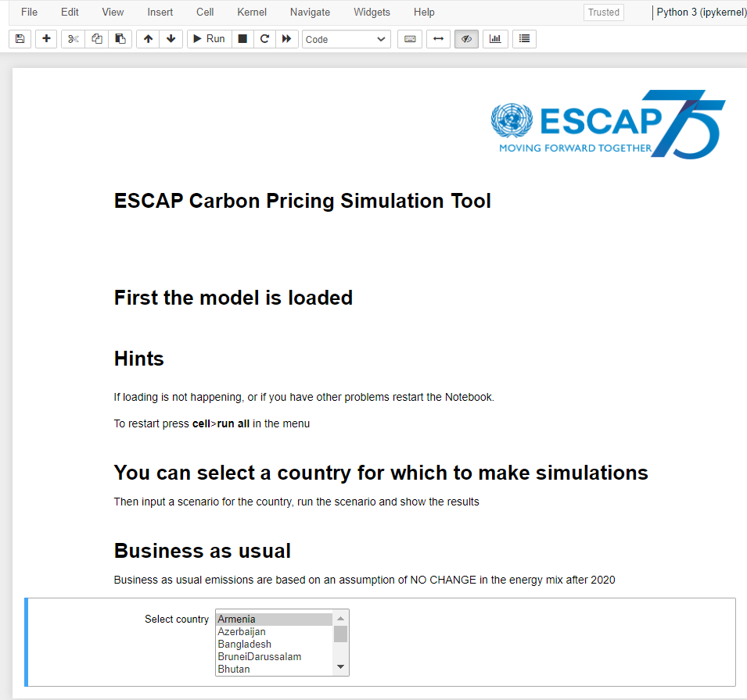

It can take some time for the tool to appear. First **a virtual machine/virtual notebook** is created, then the economic model is loaded. The time for this will depend on server capacity usage.

## How to choose input for each simulation session.

Once the model is loaded, the user can choose a country from a list of countries.

When a country is selected, three parameter tabs will appear as shown below.

Each tab can be expanded to show a choice of policy options.

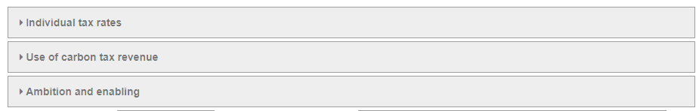

## 

## Individual tax rates.

This tab allows the user to input changes in Carbon tax rates. The tax rate is measures in USD per ton.

Note that the input is the change in the rate. So, an input of 5 in 2021 results in 5 higher tax in every year from 2021 and onwards. If in 5 is input in 2022 the tax will be 5 higher in 2021 and 10 higher from 2022 and forward.

As an example, we can look at Bangladesh,

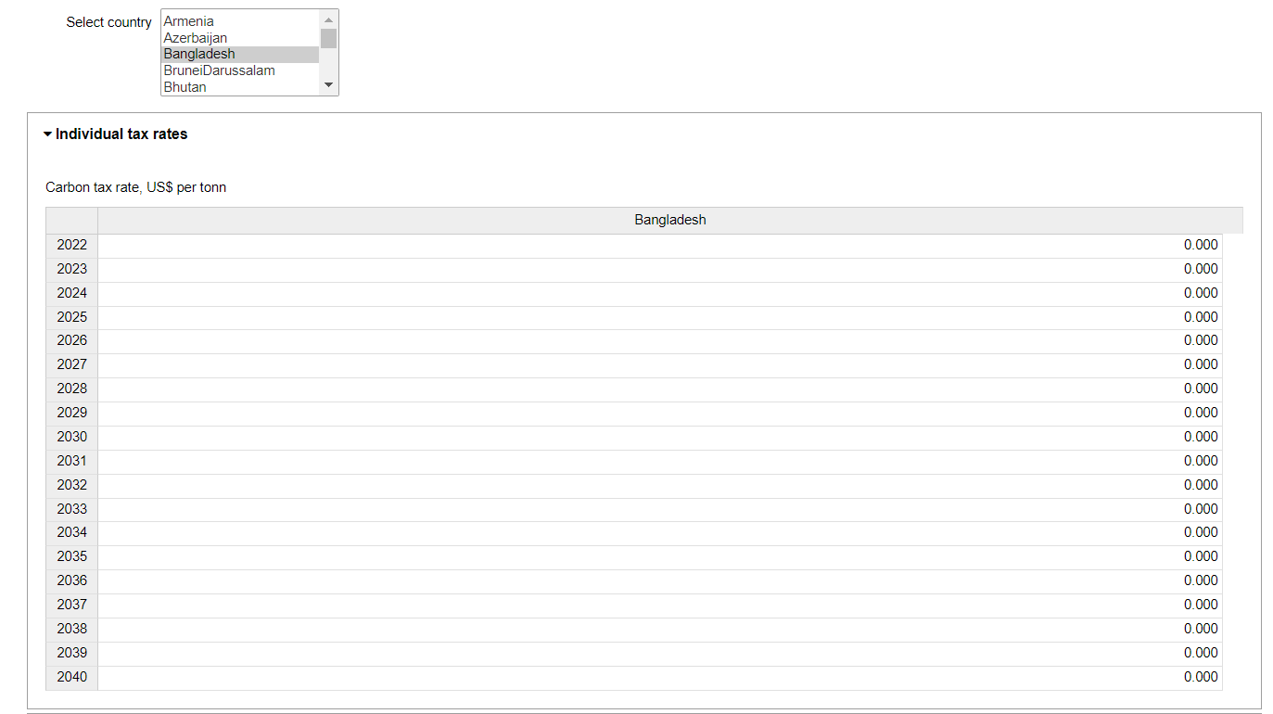

**Use of carbon tax revenue.**

This tab allows the user to input the share of the tax revenue used for different fiscal policy areas.

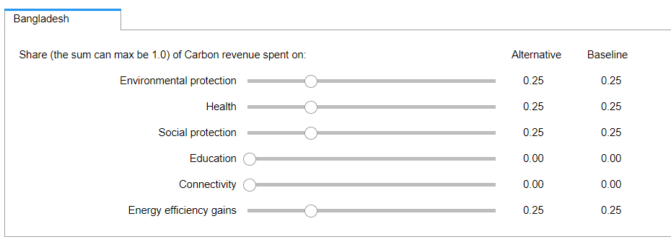

Note that the shares are constrained. A share can’t be negative and the total of the shares can’t exceed 1. The tool enforces these constraints.

**Ambition and enabling**

This tab allows inputting the Ambition and Enabling parameters. The start value is the current parameter value for the country. Both parameters value can be between 1 and 5.

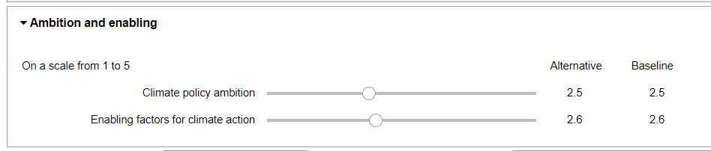

## How to run the simulation

As a default, the tool will suggest a scenario name when the input for a scenario has been updated. It might be useful to input a more meaningful name. This can be done in this field:



That will be the scenario name which will appear on a resulting chart.

Now the scenario can be simulated by pressing this button:



## Review results

When the model has completed the simulation, a resulting chart will be generated and shown. The user can select indicators to chart from this dropdown box (in this example for Bangladesh):

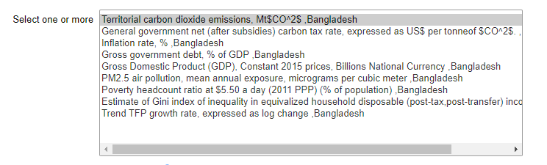

This shows the default chart after an experiment where the tax is increased by 6 USD/Ton each of the first 6 years.

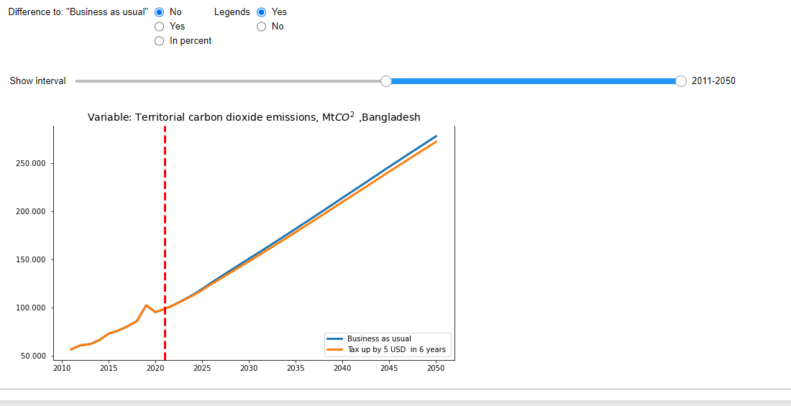

For some indicators it can be more relevant to look at the difference to "Business as usual" either in absolute terms or in percent of "Business as usual". This is achieved by selecting the appropriate button in the “Difference to Business as usual” section. For the difference it looks like this:

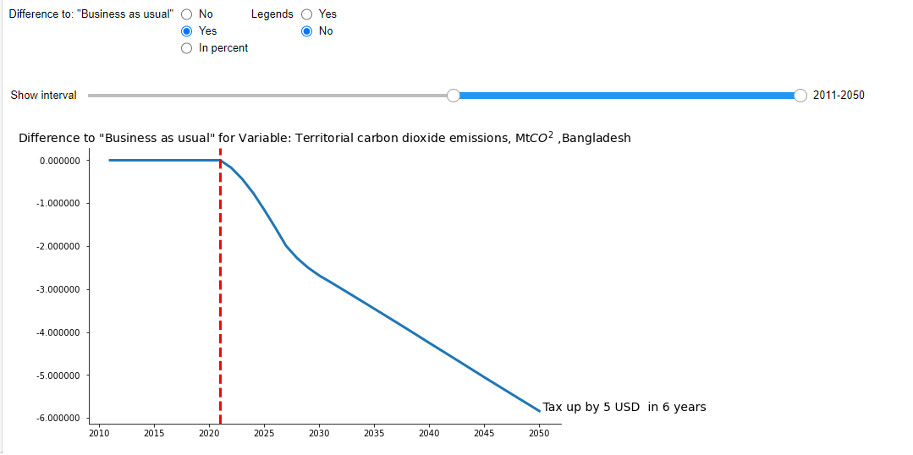

And for the difference in percent it looks like this:

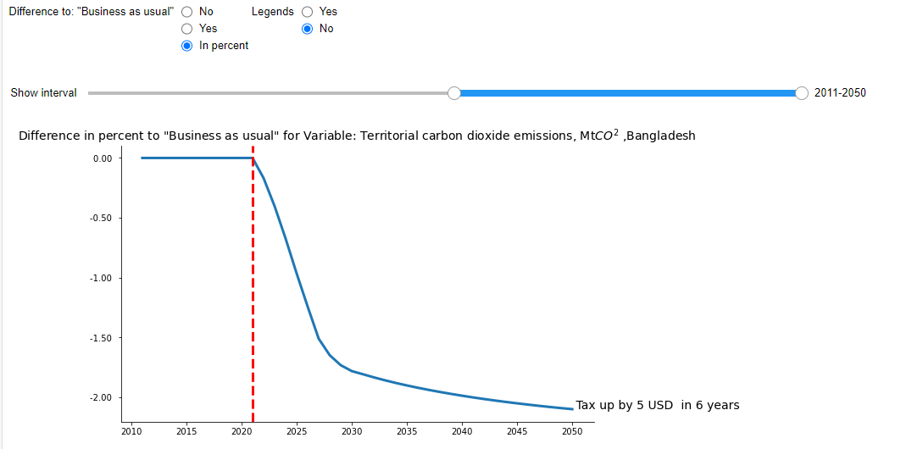

The legend button determines the placement of the scenario text. Either to the right of the scenario results, or in a legend box.

## To start a new country simulation session

To start a new country simulation session it is necessary to clear all previous results for this country. This is done by first selecting another country and then returning back to the initial country of choice.

## Trouble shooting.

If something goes wrong the user would need to restart the **virtual notebook**. This is done from the menu bar by selecting **Cell>run All**

Like this:

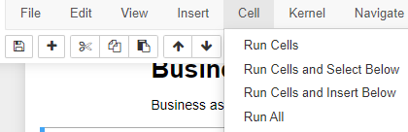

Click

Another option will be to restart the uploading of the tool again by clicking [here](https://mybinder.org/v2/gh/IbHansen/UNESCAP-Asia/HEAD?urlpath=tree/Asia/Carbon%20tax%20experiments%20singel%20country.ipynb)